Budget Development
Millennium Budget Module

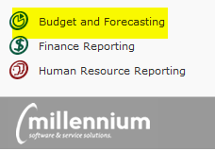

Entry and Approval of Budgets

Important Definitions:
Millennium Budget Development: The part of the Millennium Fast budget module that allows users to build and approve new fiscal year budget entries.
Class and Subclass: Budget categories required for all transactions that assist with tracking and reporting. Please see budget development instructions for a list of codes to use.
Development Menu: Main menu for budget development options.
Development Entry Menu Item: Form to view present budget entries, edit any “pending” entries, or add new budget entries.
Development (“Dev”) Series: A spreadsheet type table in Millennium used for the collection of data for the base build. In most cases, this will have a title of “FY* Build.” (ex. FY17 Build). Other Series available to view may also include the “Roll” phase.
Status: Pending Approval (or Pending), Approved or Denied, Submitted to Budgets. All records are in Pending status until Approved or Denied.
Status Indicator: Pending (yellow), Approved (green), Denied (red) circles found on the Add/View/Edit Budget Entry Records screen to the left of the Dev Series column. Quick way to see items approved/pending or denied.
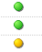
View, Edit or Delete Icon: The pencil icon allows you to edit the record. The green “check mark” allows you to view the detail behind a record but the record is locked for editing (it has already been approved and/or submitted to budget). The “X” icon will delete the record.
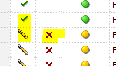

Excel Import: Excel file template used to upload changes to Development. Found on tBO website.
Review User Requests: Form used by budget approvers to approve or deny pending budget changes. This form is found under the Development menu.
Compare Development Series: A report to compare changes. Found under the “Reporting” menu.

How To Upload to Millennium Budget Development
- Prepare the WWU_Development_Template.xls upload template with all changes for the build.
Note: the base budget rolled from the previous year will already be loaded - only changes will be uploaded.
  - Template link: can be found under the Development menu at the bottom of the Excel Import screen, in the email distribution or on our website here.
  - Do not delete row 1 or 2 (with the XXXXs) on the upload template.
  - Do not include any formulas in the upload. If you paste from another document, paste as “values” so that formatting is not included.
  - Required fields: Fund, Org, Acct, Prog, Total (both increase and decrease appear in the same column. Use a negative “-“ sign for any budget decrease entries), Budget Period = 1, Classification, Subclass, Employee ID (if the entry is position based), Position code (if the entry is position based). Comments = the budget office will enter these comments and they will be standard based on the Classification / Subclass.
  - Optional fields: FAST (do not need to add Fund/Org/Prog if you use this), Additional Info= your notes/comments on the transaction (equal to 255 characters).
  - Preparation: one line per change. For example, if a faculty member has a legislative increase, T&P increase, and a retention increase, the position will have 3 separate lines in the upload with 3 different Classifications and Subclasses. For pooled positions, enter “POOLED” for the employee ID. For Vacant positions enter “VACANT” for the employee ID. Reminder: similar to budget transfers, to move dollars from one person/position to another, a reduction needs to be performed on one line and the increase needs to be performed on a second line.
  - Save template in preparation for upload.

- Open the Millennium Budget Module, select the new fiscal year (ex. 2016/2017), navigate to the Development menu and select “Excel Import.”

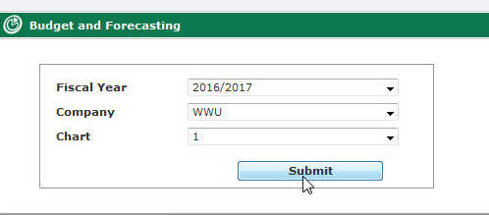

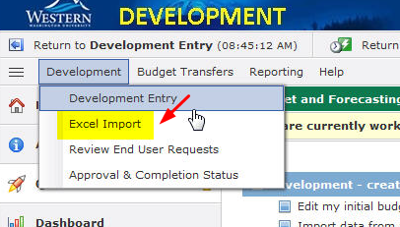

- Click on “Browse,” navigate to your saved template, highlight the file, click open and then click “Next Import Step” all the way to the right.
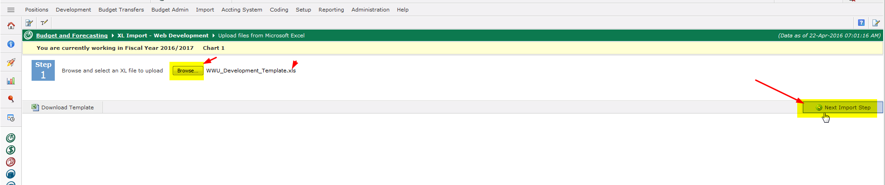

- Select the Development series to upload the data to (ex. FY17 Build) and then click on “Next Import Step” all the way to the right.
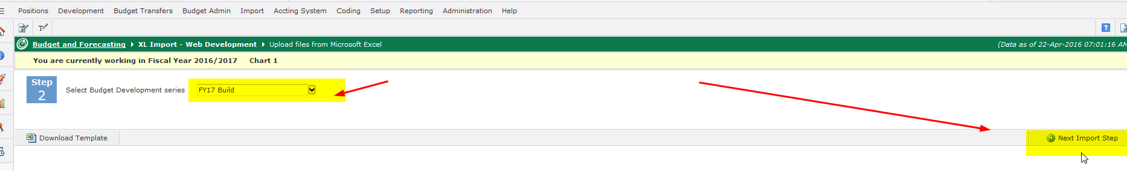
- Millennium will check against the chart of accounts for active chart elements and then give you a completed message. Click “Ok.” If there is an error, you will receive an error message and be prompted to open a pdf document that will display the lines causing the error. If there is an error, the entire upload will fail so you must correct the error and upload the document again.

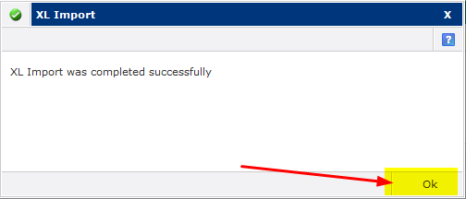

- Navigate to the Development Entry page to view or edit items uploaded.

Note: if you uploaded in error and would like the entire upload deleted, please contact the Budget Office with a mass delete request.

Viewing, Editing and Adding Budget Entries in Millennium Budget Development
- Log in to Millennium (https://millfast.admcs.wwu.edu/FastPortal_Prod/DesktopDefault.aspx )
- Click on “Budget and Forecasting”
- Select Fiscal Year and click “Submit.” For Budget Development, you will select the fiscal year in which the new budget is being built. In our example, 2016/2017
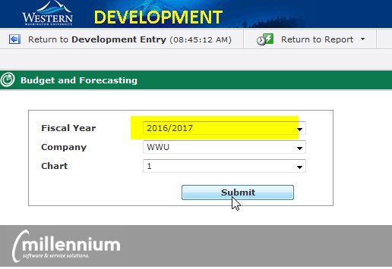

- You will see four menu options at the top of your page: Development, Budget Transfers, reporting and Help. Click on the first tab: “Development” and then “Development Entry.” Selecting Development Entry will take you to the starting point to edit and add entries to your budget.

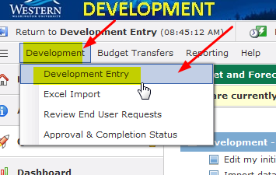

- Select the Dev Series (ex. FY17 Build) and any other filters you would like and then “Execute Report.” The report results will be displayed. This is the main screen for development entry. From here you can see what has been approved, enter new lines, edit any entries that are pending (haven’t been approved or posted), view entries that have been approved or posted, delete any rows that are pending. Each row has a circle status indicator to the left of the Dev Series column. If a record has been approved the circle is green and the record is not editable. If the circle is red, the entry has been denied. If the circle is yellow, the entry is in “pending” status and can be edited or deleted.
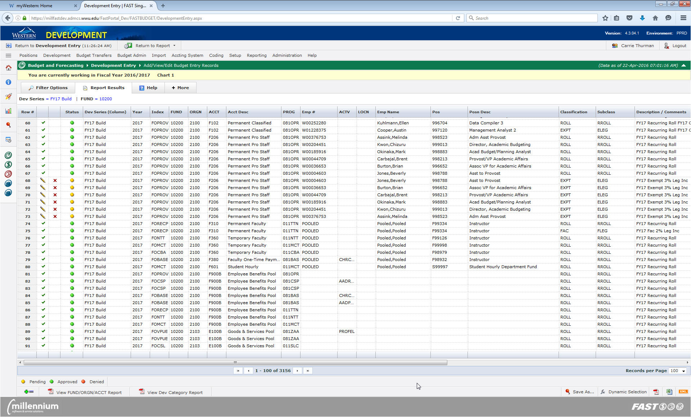
- To edit an entry, click on the “pencil” icon to bring up the entry detail report.
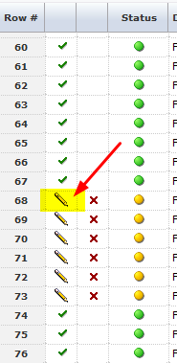

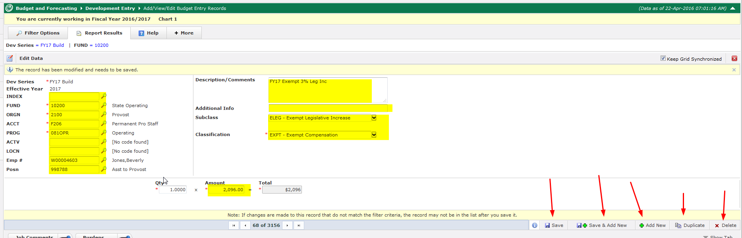
From this screen you can change Index, Fund, Orgn, Acct, Prog, Actv, Locn, Emp id, Posn, Comments, Additional Info, Classification, Subclass and amount.
- Perform all edits and click “Save” at the bottom of the entry screen. You may also duplicate, add new or delete records from this screen by using the controls at the bottom right.

- To add a new record from the main development entry screen follow steps 1-5 above. When the data loads, click the “+=” icon at the bottom of the screen. This will bring up the entry screen. Enter all info for new line and save.

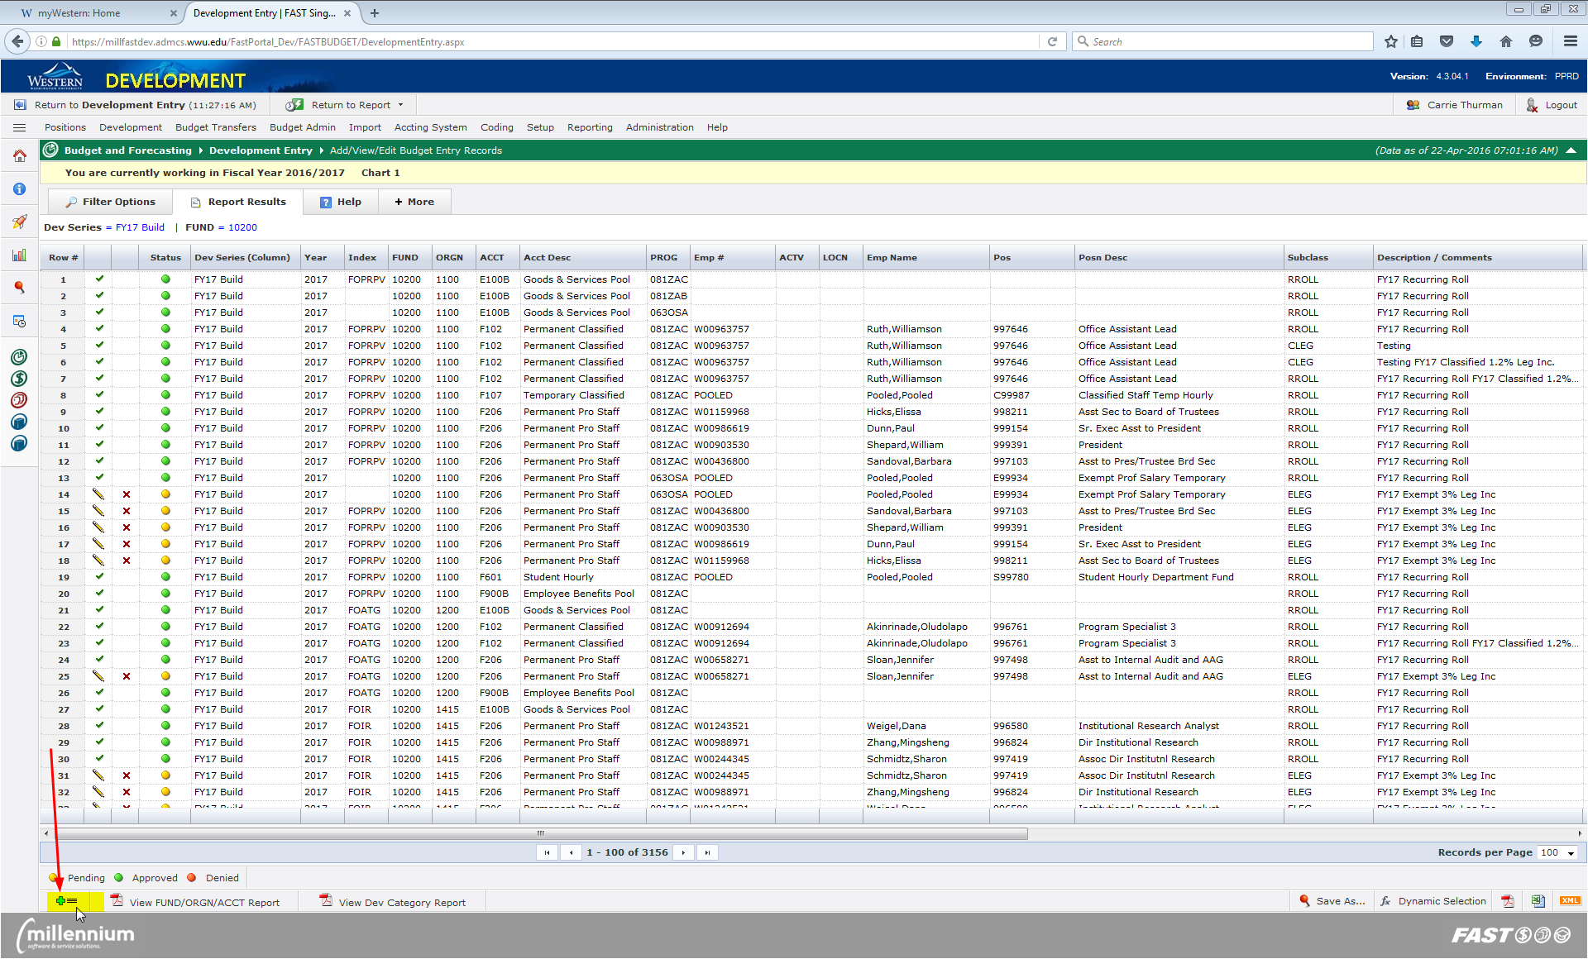

- To delete a line from the main development screen, follow steps 1-5 above and when the data loads, find the line you wish to remove and click the red “X” icon to the left of the status circles. Note: you cannot retrieve a line once it has been deleted. Click “Ok” when the dialogue box appears.
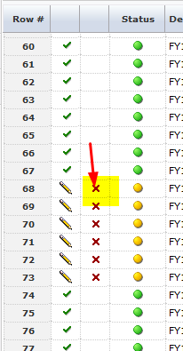

Approving Budget Entries in Millennium Budget Development
- Log in to Millennium (https://millfast.admcs.wwu.edu/FastPortal_Prod/DesktopDefault.aspx )
- Click on “Budget and Forecasting”
- Select Fiscal Year and click “Submit.” For Budget Development, you will select the fiscal year in which the new budget is being built. In our example, 2016/2017
- Go to the Development menu and select “Review End User Requests”
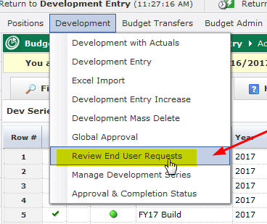
- Select the Dev Series (ex. FY17 Build) and any other filters and click “Execute Report” (bottom right).
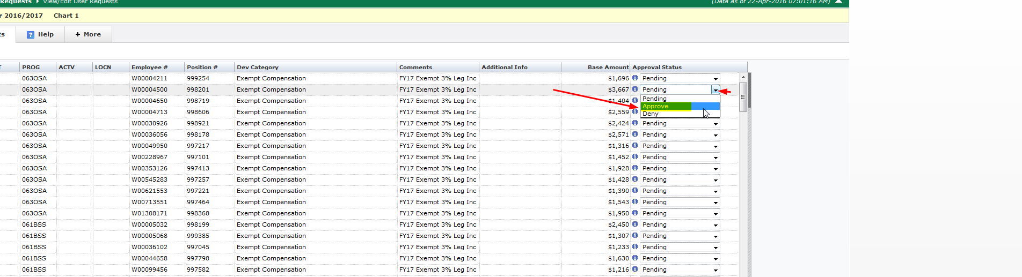
- There are two ways to approve the budget entries: line by line or mass approve.
  - To approve line by line, click the down arrow on the approval status box and change the status to either approve or deny. You may also change entries back to pending after saving as approve or deny (if the approved entries have already posted, no further changes are allowed and a new line will need to be entered to make a change). Click “Save Current Page” at the bottom of the page to save your changes.
  - To mass apply a change to all entries, select the status at the bottom of the page and click “Apply and save status.” After record status is changed, the new status will appear in the approval status column to the right.

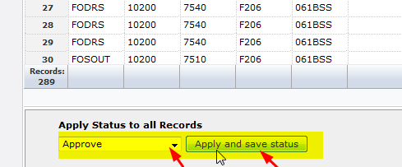

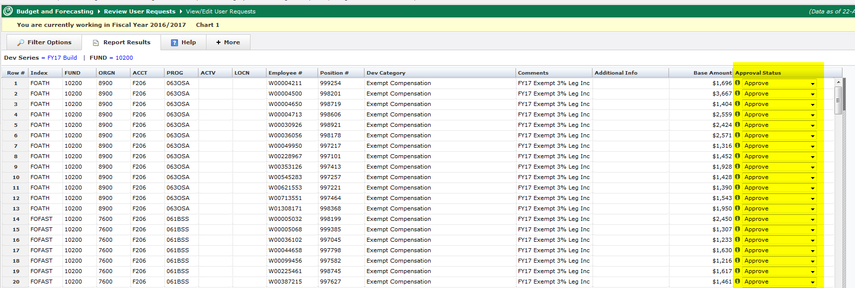

- To get an overview of all the statuses on any given fund/org combo, select “Approval & Completion Status” from the Development menu, select filter options and then click “Execute Report.” The report will load and display the total amount, count, number pending approval, number approved, number denied, number submitted to budget office and the number outstanding. If there are items pending approval, you will see a hyperlink on the report that you can click on that will take you to the Development entry screen where you can edit, delete, etc.

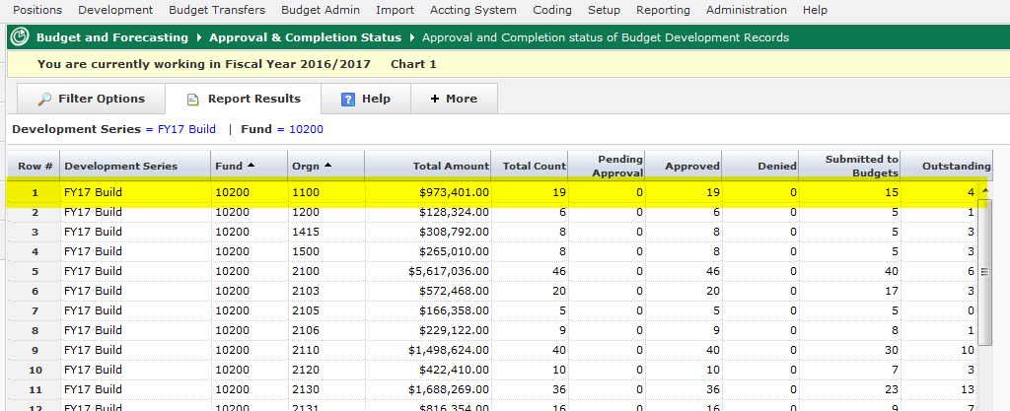

Reporting in Millennium Budget Development
In addition to Millennium’s canned “Compare Development Series” report, there are three other reports available to you as well as one pinned public report.
Under the Reporting tab, you will see three reports: Development Entry Report, Development Entry Totals by Class and Development Entry Totals by Subclass:
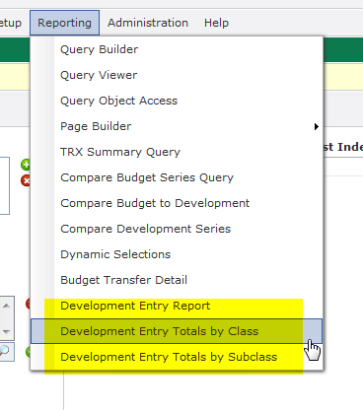

- Development Entry Report: This reports is a list of all changes that you can filter on or download to excel for further modifications. This is the report that the pinned crosstab “Development Entry Totals by Orgn” report is based on. Using this report, you can filter by any or all classifications and subclasses as well as by status (i.e. approve, pending, denied).

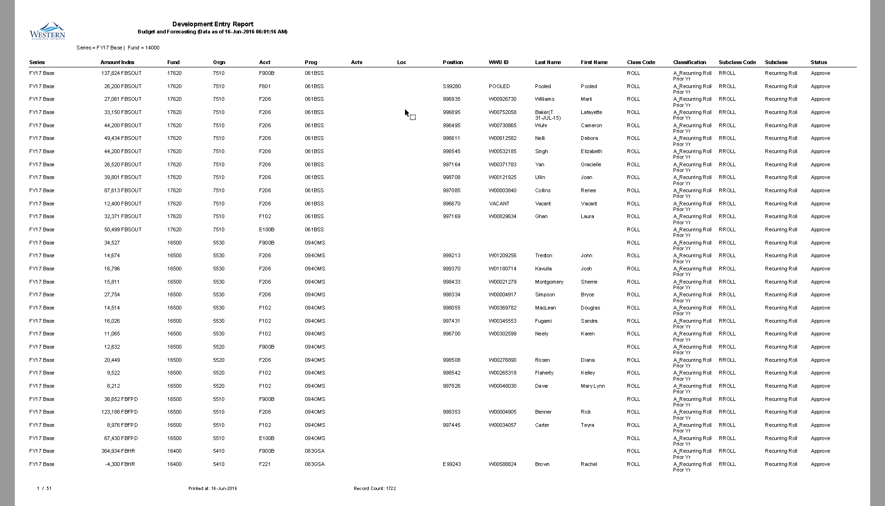
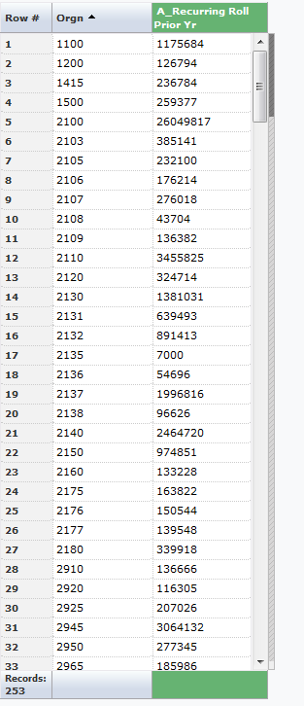
(This “Development Entry Totals by Orgn” pinned report will show all the changes in columns once they are uploaded)
- Development Entry Totals by Class: This report lists all changes for every line columns horizontally with totals at the bottom of the page (note: you can hide any columns you don’t want to see by using advanced options and unchecking the classifications):

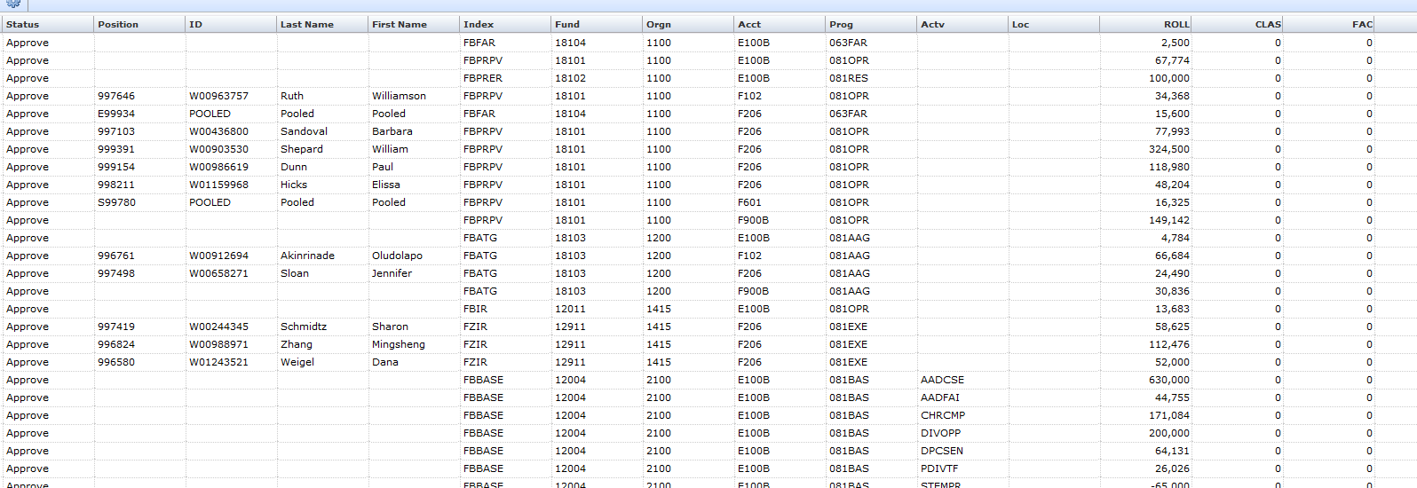
- Development Entry Totals by Subclass: Similar to the report above except it lists all the subclasses:
