Budget Development
Millennium Budget Module

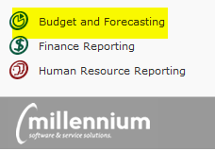

Entry and Approval of Budgets

Important Definitions:
Millennium Budget Development: The part of the Millennium Fast budget module that allows users to build and approve new fiscal year budget entries.
Class and Subclass: Budget categories required for all transactions that assist with tracking and reporting. Please see budget development instructions for a list of codes to use.
Development Menu: Main menu for budget development options.
Development (“Dev”) Series: A spreadsheet type table in Millennium used for the collection of data for the base build. In most cases, this will have a title of “FY* Build.” (ex. FY18 Build).
Development Entry Menu Item: Form to view present budget entries, edit any “pending” entries, or add new budget entries.
Budget Report Menu Item: Report to compare present development budget with actuals and/or other series. May also “quick enter” into development series from this screen.
Status: Pending Approval (or Pending), Approved or Denied, Submitted to Budgets. All records are in Pending status until Approved or Denied.
Status Indicator: Pending (yellow), Approved (green), Denied (red) circles found on the Add/View/Edit Budget Entry Records screen to the left of the Dev Series column. Quick way to see items approved/pending or denied.
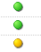
Excel Import: Excel file template used to upload changes to Development. Found on tBO website.
Review User Requests Menu Item: Form used by budget approvers to approve or deny pending budget changes. This form is found under the Development menu.
Compare Budget to Development Series: A report to compare last year’s adjusted budget (ex. FY17 Subledger) with the budget development series. Found under the “Reporting” menu.
Development Entry Report: The report used to see all the detail of the base budget build. Reporting menu.
Development Entry Totals by Subclass: Line items by subclass code. Reporting menu.
Development Entry Totals by Class: Line items by class code. Reporting menu.

How To Download Data for View or Analysis
If you would like to download the roll data in order to view it in excel or to perform analysis for increases, etc, you may do so directly in the Development Entry series.
- Open Millennium Budget, select the fiscal year you are building the budget for, navigate to the Development menu and select “Development Entry.”
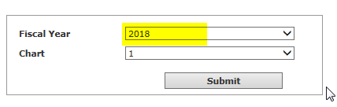
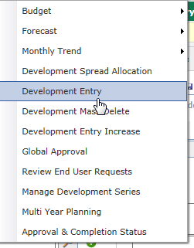
- Select the Dev Series (ex. FY18 Build), select a Class of “ROLL” along with any other filters you would like and then “Execute Report.” The report results will be displayed.

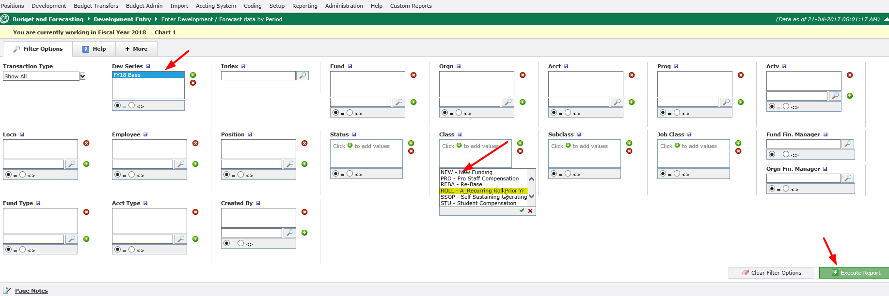

- Click on the excel Icon at the bottom right of the screen and then select Open or Save on the pop-up box. Data will be exported to excel.
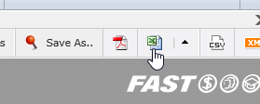

How To Upload To Millennium Budget Development
- Download Excel Template from Development Entry Screen or use template found on the tBO site.
Note: the base budget rolled from the previous year will already be loaded - only changes will be uploaded.
  - Template link: can be found under the Development menu at the bottom of the Excel Import screen, in the email distribution or on our website here.
  - Do not include any formulas in the upload. If you paste from another document, paste as “values” so that formatting is not included.
  - Required fields: Fund, Org, Acct, Prog, Amount (Enter Amount in the “Amount” column AND in the month or months desired. Use a negative “-“ number for any budget decrease entries and a positive number for any budget expense increase entries), Class, Subclass, Employee ID (if the entry is position based), Position code (if the entry is position based), Description (please read directions to see if there are any standard comments required for certain increases funded centrally).
  - Optional fields: FAST (do not need to add Fund/Org/Prog if you use this), Additional Comments= your notes/comments on the transaction (equal to 255 characters).
  - Preparation: one line per change. For example, if a faculty member has a legislative increase, T&P increase, and a retention increase, the position will have 3 separate lines in the upload with 3 different Class and Subclass codes. For pooled positions, enter “POOLED” for the employee ID. For Vacant positions enter “VACANT” for the employee ID. Reminder: similar to budget transfers, to move dollars from one person/position to another, a reduction needs to be performed on one line and the increase needs to be performed on a second line.
  - Save template in preparation for upload.

- Once you have your upload prepared, open the Millennium Budget Module, select the new fiscal year (ex. 2018), navigate to the Development menu and select “Excel Import.”

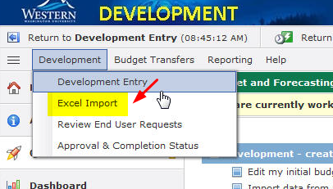

- Click on “Browse,” navigate to your saved template, highlight the file, click open and then click “Next Import Step” all the way to the right.
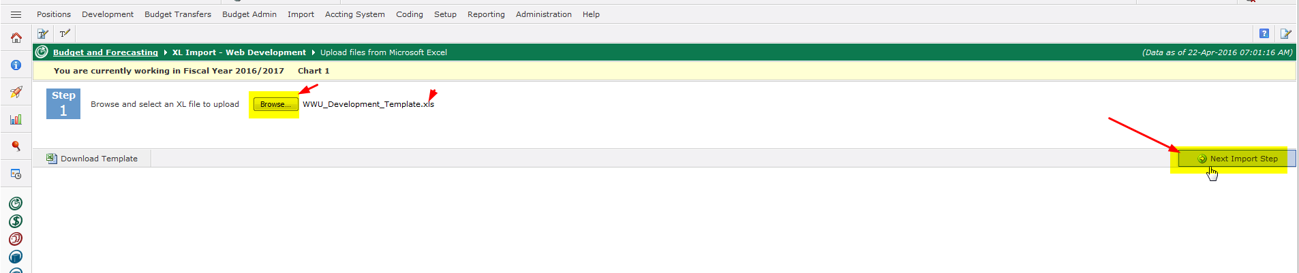
- Select the Development series to upload the data to (ex. FY18 Build) and then click on “Next Import Step” all the way to the right.
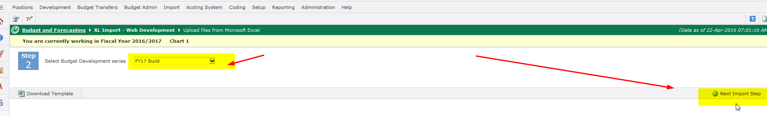
- Millennium will check against the chart of accounts for active chart elements and then give you a completed message. Click “Ok.” If there is an error, you will receive an error message and be prompted to open a pdf document that will display the lines causing the error. If there is an error, the entire upload will fail so you must correct the error and upload the document again.

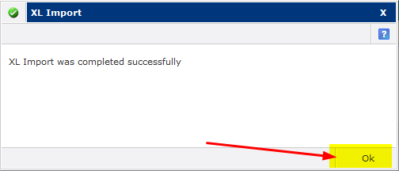

- Click Ok to exit.
- Navigate to the Development Entry page to view or edit items uploaded.
Note: if you uploaded in error and would like the entire upload deleted, please contact the Budget Office with a mass delete request. Have the excel import number handy (to the right on the Development Entry screen called “XL Import Log).

Viewing, Editing and Adding Budget Entries in Millennium Budget Development
- Log in to Millennium (https://millfast.admcs.wwu.edu/FastPortal_Prod/DesktopDefault.aspx)
(or test: https://millfastdev.admcs.wwu.edu/FastPortal_Dev/DesktopDefault.aspx )
- Click on “Budget and Forecasting”
- Select Fiscal Year and click “Submit.” For Budget Development, you will select the fiscal year in which the new budget is being built. In our example, 2018
- You will see four menu options at the top of your page: Development, Budget Transfers, reporting and Help. Click on the first tab: “Development” and then “Development Entry.” Selecting Development Entry will take you to the starting point to edit and add entries to your budget.

- Select the Dev Series (ex. FY18 Build) and any other filters you would like and then “Execute Report.” The report results will be displayed. This is the main screen for development entry. From here you can see what has been approved, enter new lines, edit any entries that are pending (haven’t been approved or posted), view entries that have been approved or posted, and delete any rows that are pending. Each row has a circle status indicator to the left of the Dev Series column. If a record has been approved the circle is green and the record is not editable. If the circle is red, the entry has been denied. If the circle is yellow, the entry is in “pending” status and can be edited or deleted.

- To edit a pending entry (yellow circle all the way to the left), click on any of the editable fields (ex. Acct, Emp %, Amount, etc., and enter the change) and then click “Save” - little disc next to the “+New” button. Note: once you change a record, the original data will be overwritten with the new data. Only the person who has added or uploaded the line can edit the record. However, anyone can add a new line to make an adjustment for the same FOAPAL/Employee string.

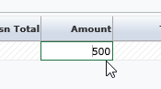

Click field to change data and then save to update a record

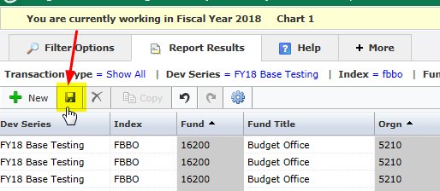
Save = disc button. You may save after each change or make multiple updates and/or add lines and then save before exiting.

- To add a new line, click the “+New” icon at the top left of the Development Entry Screen the screen or, if you are at the end of a row and tab, a new line will appear. Enter all info for new line and save.

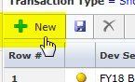

- To delete a line from the main development screen, highlight the row you’d like to delete, and then click the red “X” in the upper left corner of the screen. Note: Save changes or delete will not occur.
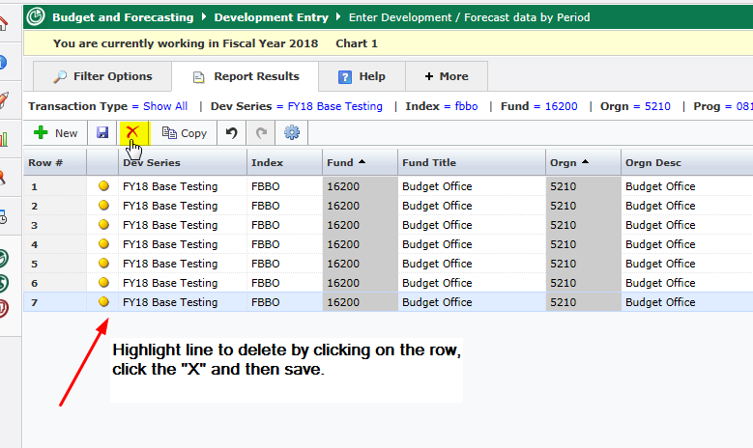

Approving Budget Entries in Millennium Budget Development
- Log in to Millennium (https://millfast.admcs.wwu.edu/FastPortal_Prod/DesktopDefault.aspx )
- Click on “Budget and Forecasting”
- Select Fiscal Year and click “Submit.” For Budget Development, you will select the fiscal year in which the new budget is being built. In our example, “2018”
- Go to the Development menu and select “Review End User Requests”
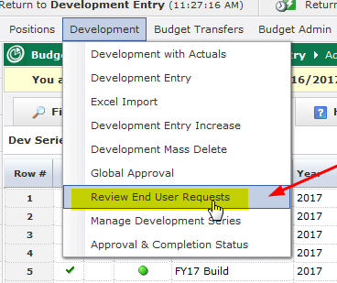
- Select the Dev Series (ex. FY18 Build) and any other filters and click “Execute Report” (bottom right).
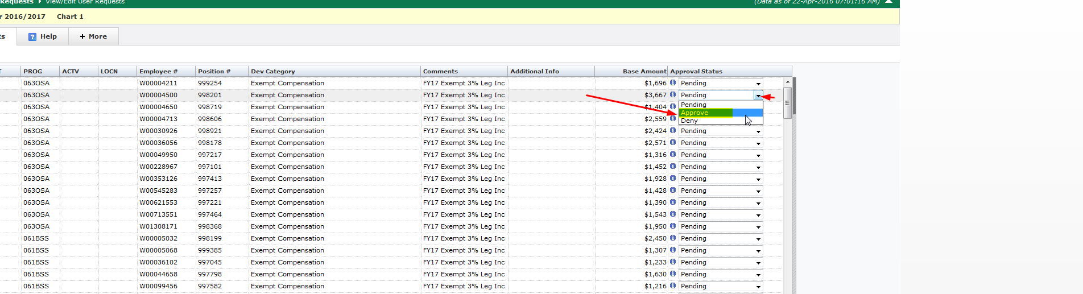
- There are two ways to approve the budget entries: line by line or mass approve.
  - To approve line by line, click the down arrow on the approval status box and change the status to either approve or deny. You may also change entries back to pending after saving as approve or deny (if the approved entries have already posted, no further changes are allowed and a new line will need to be entered to make a change). Click “Save Current Page” at the bottom of the page to save your changes.
  - To mass apply a change to all entries, select the status at the bottom of the page and click “Apply and save status.” After record status is changed, the new status will appear in the approval status column to the right.

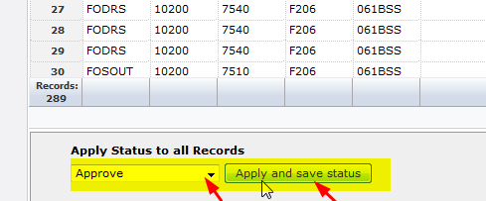

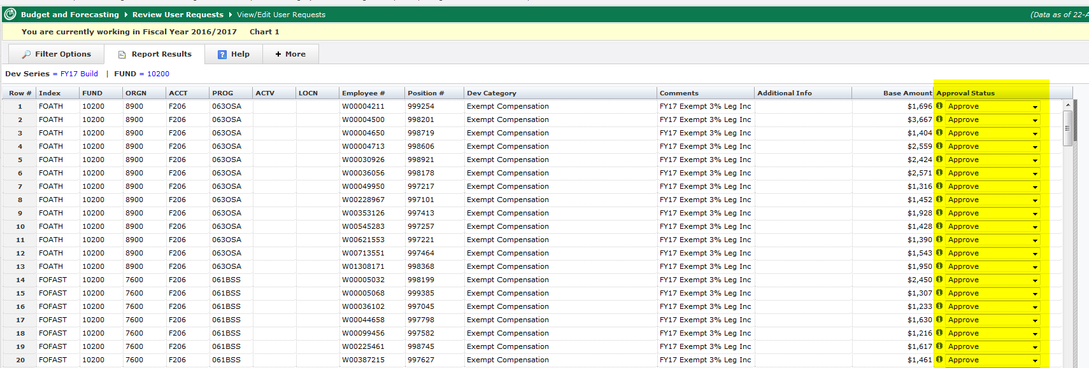

- To get an overview of all the statuses on any given fund/org combo, select “Approval & Completion Status” from the Development menu, select filter options and then click “Execute Report.” The report will load and display the total amount, count, number pending approval, number approved, number denied, number submitted to budget office and the number outstanding. If there are items pending approval, you will see a hyperlink on the report that you can click on that will take you to the Development entry screen where you can edit, delete, etc.

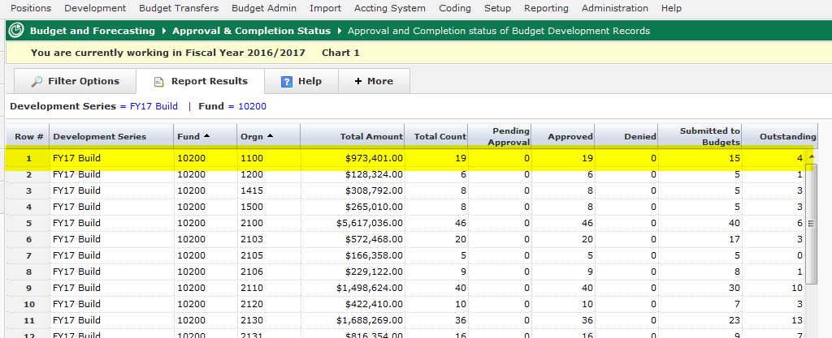
Reporting in Millennium Budget Development
In addition to Millennium’s canned “Budget Report” and “Compare Development Series” report, there are three other reports available to you as well as one pinned public report.
Under the Reporting tab, you will see three reports: Development Entry Report, Development Entry Totals by Class and Development Entry Totals by Subclass:
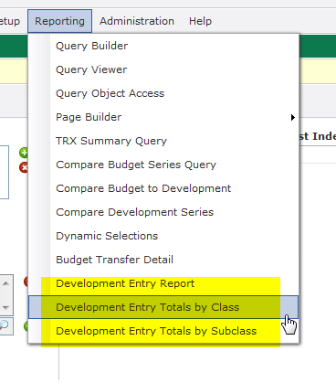

- Development Entry Report: This reports is a list of all changes that you can filter on or download to excel for further modifications. This is the report that the pinned crosstab “Development Entry Totals by Orgn” report is based on. Using this report, you can filter by any or all classifications and subclasses as well as by status (i.e. approve, pending, denied).

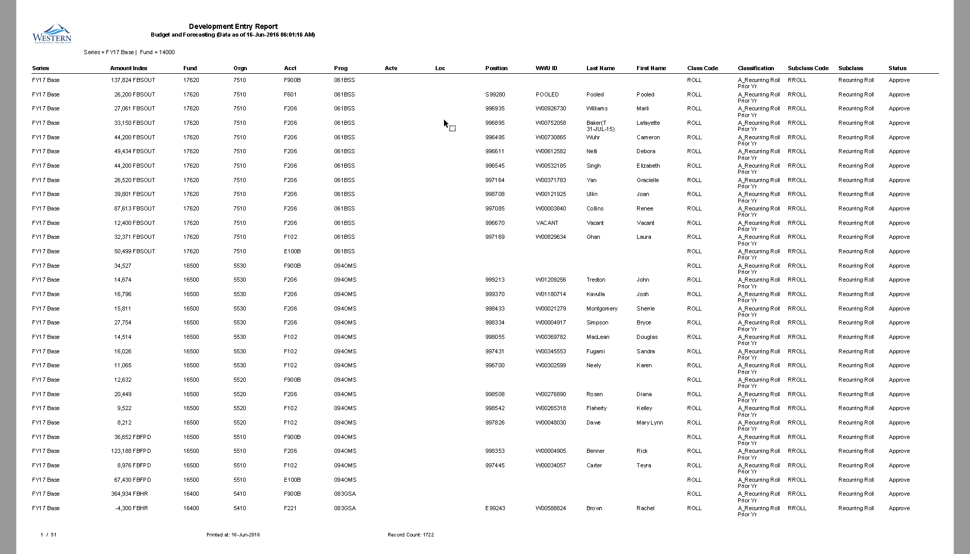
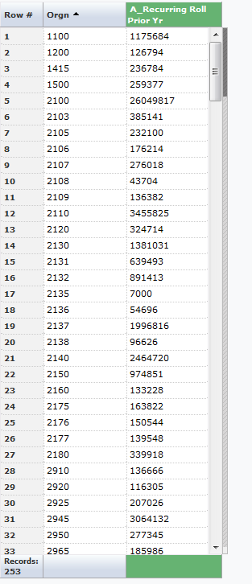
(This “Development Entry Totals by Orgn” pinned report will show all the changes in columns once they are uploaded)
- Development Entry Totals by Class: This report lists all changes for every line columns horizontally with totals at the bottom of the page (note: you can hide any columns you don’t want to see by using advanced options and unchecking the classifications):

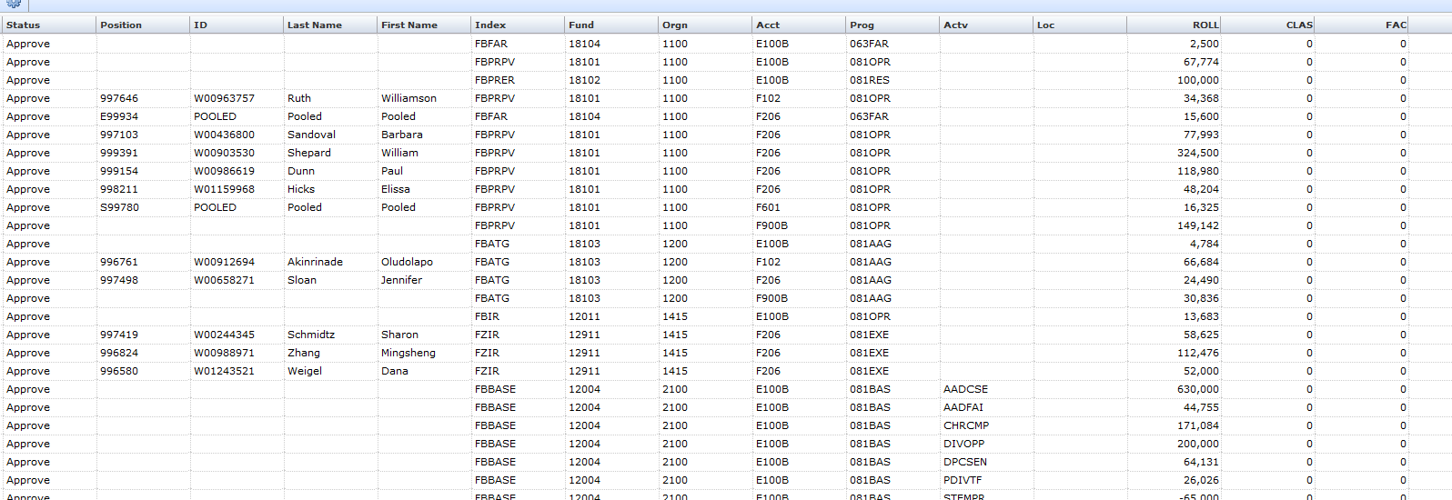
- Development Entry Totals by Subclass: Similar to the report above except it lists all the subclasses:
